Skyline and Small Molecules

The Skyline Targeted Proteomics Environment provides informative visual displays of the raw mass spectrometer data you import into your Skyline documents. Originally developed for proteomics use, Skyline has been extended to work with generalized small molecules. There are many tutorials available that will help you use Skyline for various types of analysis (SRM, MS1 Filtering, DIA, Targeted MS/MS etc), this tutorial concentrates on the differences in using Skyline with small molecules.

In this tutorial, we are building an MRM assay for a group of Methionine-pathway compounds.

Skyline aims to provide a vendor-neutral platform for targeted proteomics investigation. It can import raw data from the instrument vendors AB Sciex, Agilent, Bruker, Shimadzu, Thermo-Scientific and Waters. The ability to import data across various instrument platforms greatly facilitates cross-instrument comparisons and large multi-site studies.

# Getting Started

To start this tutorial, download the following ZIP file:

<https://skyline.gs.washington.edu/tutorials/SmallMolecule.zip>

Extract the files in it to a folder on your computer, like:

C:\Users\brendanx\Documents

This will create a new folder:

C:\Users\brendanx\Documents\SmallMolecule

It will contain all the files necessary for this tutorial. Now start Skyline, and you will be presented with a new empty document.

# Importing a Small Molecule Transition List into a Skyline Document

The easiest way to get a small molecule transition list into a Skyline document is to start with an empty document and use the Edit menu’s **Insert / Transition List** function. [Note: the **File / Import /Transition List** menu item does not yet work for non-proteomic data – it’s not good at guessing which columns are which in a small molecule transition list.]

At a minimum, Skyline needs to know the charge state and either the ion formula or m/z for each precursor and product. If no product ion information is present, it’s assumed to be a list of precursor targets.

### A note on ion formulas

In proteomics applications Skyline can safely assume ionization by protonation, so all that’s needed to describe a charged peptide is its sequence and charge state, Skyline just adds hydrogens to the underlying chemical formula as needed. In generalized small molecules, however, ionization can be achieved by almost any means (sodium gain, hydrogen loss, etc). The most reliable and flexible way to describe this is to Skyline is with ion formulas. That is, if your singly charged molecule is ionized by sodium gain, you must add a sodium to the chemical formula before plugging it in to Skyline. (Note: it’s also possible to describe your transition list completely in terms of m/z values, but without a chemical formula Skyline can’t provide isotopic distributions).

For our example, locate the “SMTutorial_TransitionList.csv” file and open it in Excel or any other suitable viewer.

Then start Skyline, and begin a new, empty document.

From the **Edit** menu, choose **Insert** then click on **Transition List…**

You may see this:

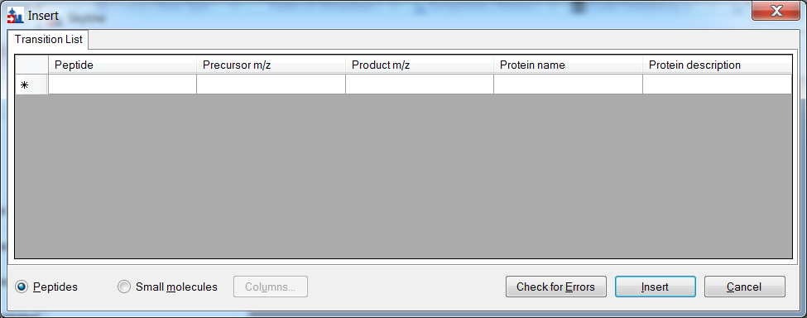

But if you select the “Small molecules” button you will see something like this:

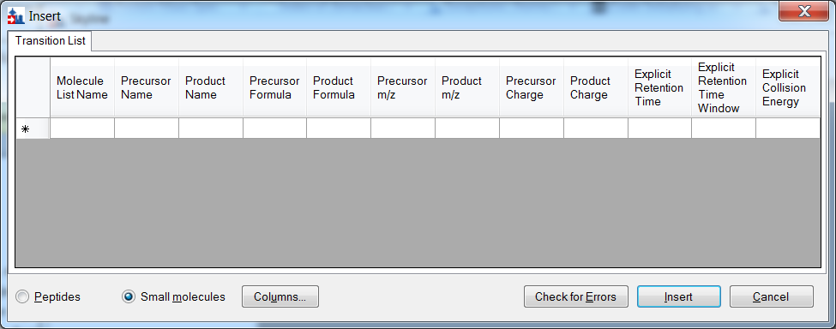

Now looking at our transition list:



We see that there are some extra column headers in the Insert dialog, and some aren’t in the same order as ours. This is easy to deal with: click the Columns button and uncheck the columns we don’t need.

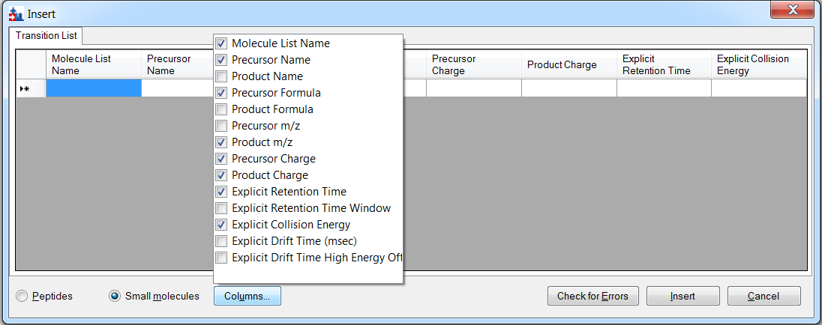

Then click and drag the column headers around until they are in the order we want:

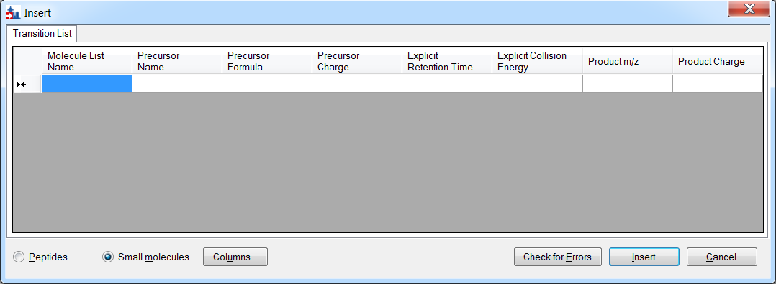

Then copy and paste the contents of the CSV file into the **Insert** dialog, and click the **Check for Errors** button.

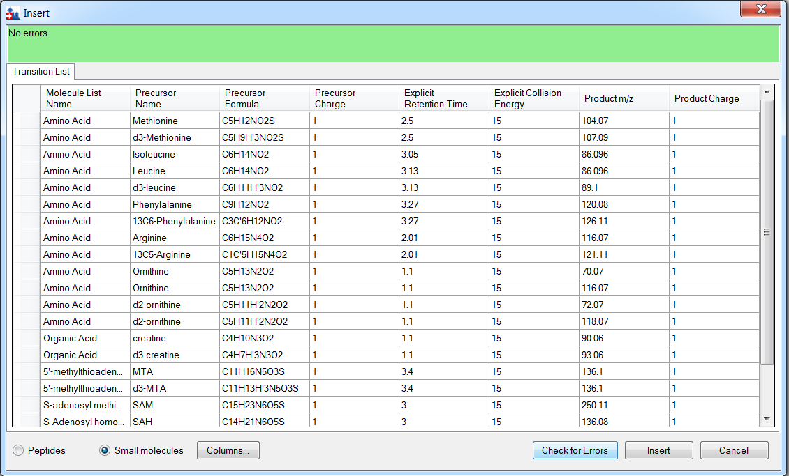

If that shows no errors, then click the **Insert** button and you should see this:

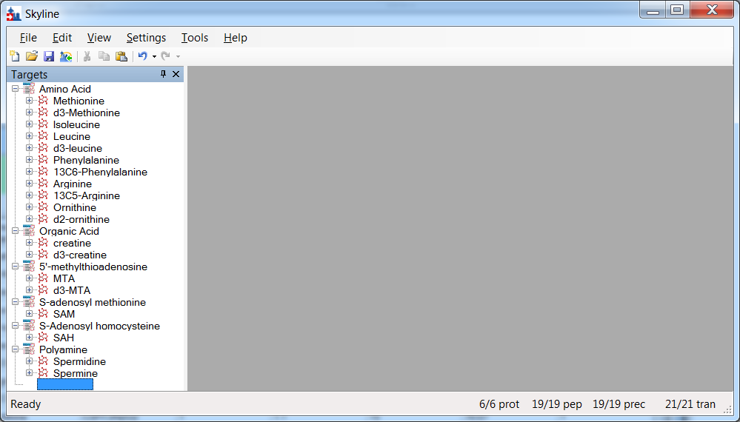

Note that some of these are pretty obviously heavy/light label pairs – Skyline doesn’t handle that yet for small molecules but will do so very soon.

At this point, either a native instrument method, precursor isolation list (for PRM) or transition list (for MRM) can be exported. For more details on how to perform this step, please see the [Skyline Existing Experiments Tutorial](https://skyline.gs.washington.edu/labkey/wiki/home/software/Skyline/page.view?name=tutorial_existing_quant).

Let’s assume this has been done, and load the raw mass spec data from the mass spec run.

First, save your Skyline document. Let’s call it “mydoc.sky” and save it in the current directory with the tutorial data.

On the **File** menu, select **Import** and click on **Results…**

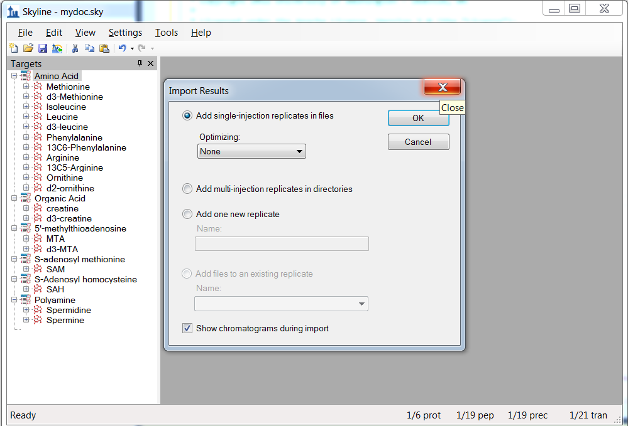

Choose “Add single-injection replicates in files” with “Optimizing” set to “None” and click OK. Select all the raw files provided with the tutorial, which are from an experiment where cells were deprived of either the amino acid Methionine, or Arginine, or both, for a period of 3 hours versus control (all amino acids). The data is part of the publication Tang X et al “Comprehensive profiling of amino acid response uncovers unique methionine-deprived response dependent on intact creatine biosynthesis”, *PLOS Genetics* **2015**.

The raw data files are in the same directory as the CSV file containing the transition list.

Filenames and Conditions:

ID15739_01_WAA263_3976_020415 – double blank

ID15740_01_WAA263_3976_020415 – Extraction Blank (contains SIL standards)

ID15740_02_WAA263_3976_020415 – Extraction Blank (contains SIL standards)

ID15740_04_WAA263_3976_020415 – Extraction Blank (contains SIL standards)

ID15655_01_WAA263_3976_020415 – All AA Sample 1

ID15656_01_WAA263_3976_020415 – All AA Sample 2

ID15657_01_WAA263_3976_020415 – All AA Sample 3

ID15658_01_WAA263_3976_020415 – Minus Met Sample 1

ID15659_01_WAA263_3976_020415 – Minus Met Sample 2

ID15660_01_WAA263_3976_020415 – Minus Met Sample 3

ID15661_01_WAA263_3976_020415 – Minus Arg Sample 1

ID15662_01_WAA263_3976_020415 – Minus Arg Sample 2

ID15663_01_WAA263_3976_020415 – Minus Arg Sample 3

ID15664_01_WAA263_3976_020415 – Minus Arg, Minus Met Sample 1

ID15665_01_WAA263_3976_020415 – Minus Arg, Minus Met Sample 2

ID15666_01_WAA263_3976_020415 – Minus Arg, Minus Met Sample 3

ID15741_01_WAA263_3976_020415 – Pooled QC Sample 1

ID15741_02_WAA263_3976_020415 – Pooled QC Sample 2

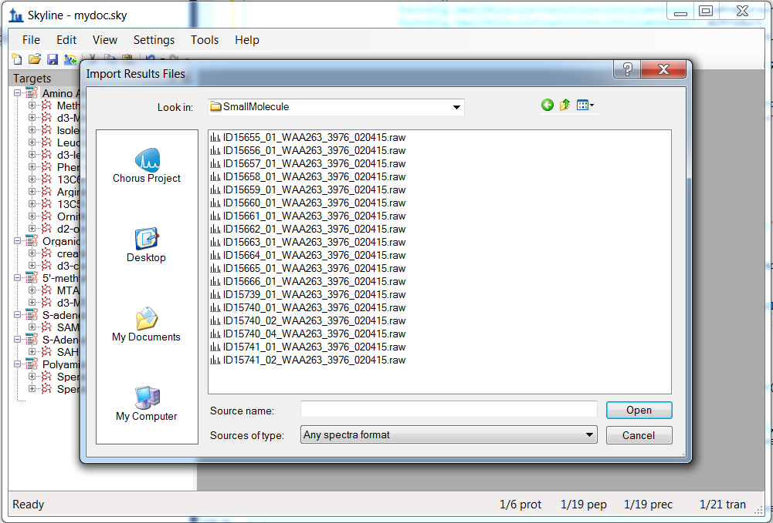

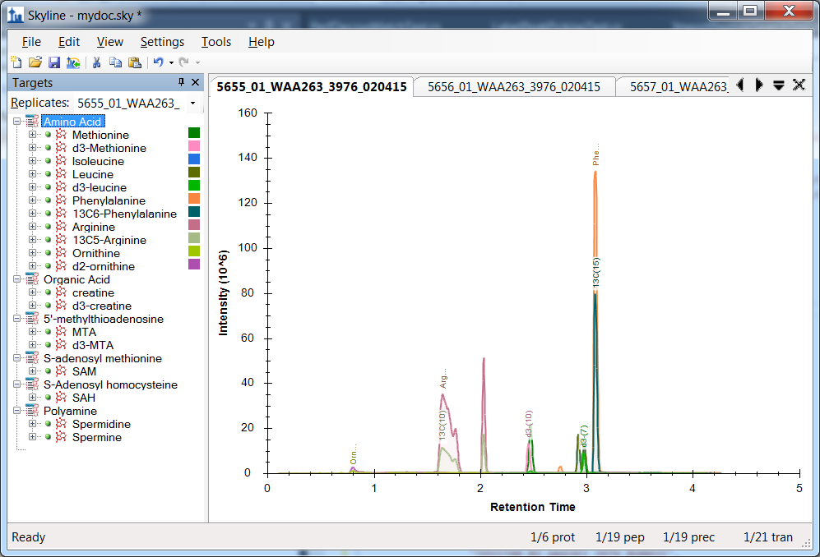

# 

# Conclusion

In this tutorial, you have learned some of the most basic and critical features for using Skyline to extract quantitative information from the MS1 scans in your DDA experiment data. Fortunately, much of the previously existing Skyline functionality still applies equally well to MS1 extracted chromatograms as to the SRM chromatograms for which it was originally designed. It is, therefore, recommended that you spend significant time understanding the material presented in the other Skyline tutorials and instructional videos. Though the idea of using chromatogram peak areas extracted from MS1 scans has be around for a long time, MS1 Filtering is still a relatively new feature area for Skyline. As such, you can expect it to continue improving rapidly.

# Supplement

If you are interested in reviewing the real data sets processed for the original MS1 Filtering paper1, visit the following link, where you can download documents that have been minimized as described above:

<http://proteome.gs.washington.edu/supplementary_data/MS1_Filtering/minimized/>

You can browse the parent directory for full Skyline documents and raw data.

# Bibliography

1. Schilling, B. *et al.* Platform-independent and Label-free Quantitation of Proteomic Data Using MS1 Extracted Ion Chromatograms in Skyline APPLICATION TO PROTEIN ACETYLATION AND PHOSPHORYLATION. *Mol Cell Proteomics* **11,** 202–214 (2012).

2. Jaffe, J. D. *et al.* Accurate Inclusion Mass Screening. *Mol Cell Proteomics* **7,** 1952–1962 (2008).